**Stating the Problem**

Calculating the sum of digits of the number entered.

**Input / Output Description**

**C:\Projects\Homework2\IO Description.png**

**Hand Example**

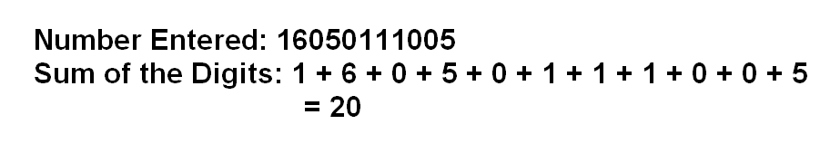

**Algorithm Development**

1. Define variables for digits, digit numbers, sum of digits, number orders and loop counter.

2. Start a loop for calculations.

3. Ask the number's digit quantity from the user. If the number entered is zero, go to Step 7.

4. Ask the number's digits in order from the user.

5. Calculate and print the sum of entered digits.

6. Get back to Step 3.

7. Terminate the program.

**Flowchart**

**C:\Projects\Homework2\Flowchart.png**

**Console Example**

